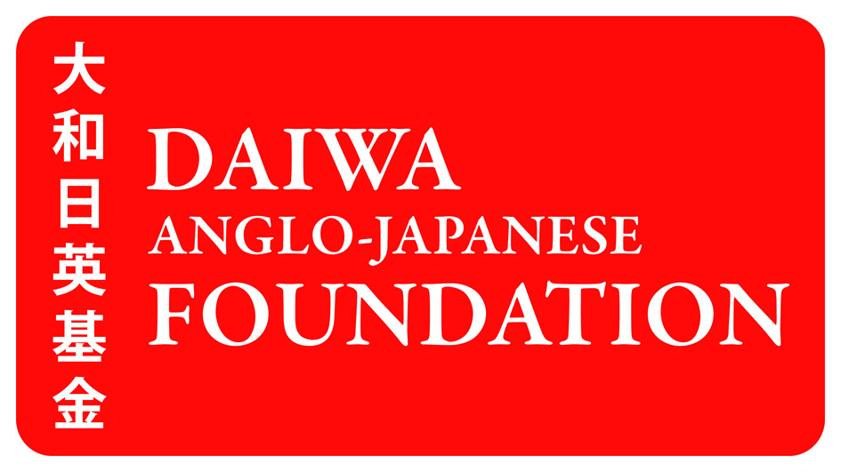

Grant Report Form and Notes

Please read these Notes before completing the Report Form.

COMPLETING THE REPORT FORM

- The Report Form is designed for use on a computer but can be printed and completed in BLACK ink by hand using CAPITAL LETTERS or with a typewriter.
- Enter text in or tick the boxes provided. DO NOT ALTER ANY OTHER PART OF THE FORM.
- The form MUST be completed in English. Any financial information MUST be given in Pounds Sterling (UK£).

Section 1 – Project Leader
The Project Leader is the person or organisation who led the project and was responsible for administering a grant.

Section 2 – Project Partner(s)
Project Partners are the people or organisations who worked with you on your project. If you had any Project Partners, please give their details.

Section 3 – Project
Select which type of grant you received: a Daiwa Foundation Small Grant OR a Daiwa Foundation Award. Enter a brief project description, the start and finish dates.

Section 4 – Grant received budget
Give the budget for the amount you received from the Foundation. Please state EXACTLY how you used the funds in Pounds Sterling (UK£). Please keep in mind the MAXIMUM rate that the Foundation can fund for the following items:

- Return flight between the UK and Japan - £750 per person
- Subsistence (including accommodation) - £100 per person per day

Please also be aware of what the Foundation cannot fund.

Daiwa Foundation Small Grants cannot be used for:  - general appeals  - capital expenditure (eg, building refurbishment, equipment acquisition, etc)  - consumables (eg, stationery, scientific supplies, etc)  - school, college or university fees  - research or study by an individual school/college/university student  - salary costs or professional fees  - commissions for works of art  - retrospective grants  - replacement of statutory funding  - commercial activities | Daiwa Foundation Awards cannot be used for:  - any project that does not involve both a British and a Japanese partner  - general appeals  - capital expenditure (eg, building refurbishment, equipment acquisition, etc)  - salary costs or professional fees  - commissions for works of art  - retrospective grants  - replacement of statutory funding  - commercial activities

Section 5 – Income for project fro other funding bodies
Please state any other funding bodies that supported the project. Only include funding that affected the project, not general financial support.

Section 6 – People exchanges
Please give details of any people exchanges between the UK and Japan that occurred as part of the project.

Section 7 – Brief outline of project
Please give a brief description of the objectives of your project. Word limit: 150 words.

Section 8 – Project objectives and achievements
Please summarise to what extent the objectives of the project were achieved. Word limit: 150 words.

Section 9 – Future developments
Please state what future developments will arise from the project, including collaborations with new and existing partners. Word limit: 150 words

Section 10 – UK-Japan links
Please state how any future developments will lead to new or enhanced links between the UK and Japan. Word limit: 150 words

Section 11 – Additional comments and supplementary material
We would welcome any additional comments about your project or your links between the UK and Japan. Word limit: 150 words

If you have included any supplementary materials with your report, please list them here.

The Foundation welcomes photographs of a project and these can be sent with the Report Form or by email to grants@dajf.org.uk (with the grant type and reference number in the subject line). Please date the photographs, state what each image portrays and give the photographer’s credit (if appropriate).

Any image sent to the Foundation may be used for publicity purposes. By sending an image to the Foundation, you are giving permission for it to be reproduced.

Section 12
Print ONE copy SINGLE-SIDED on PLAIN WHITE PAPER. Sign and date the form, and then post it to the Foundation (see the box below for the appropriate address). We recommend that you keep a copy for your records.

Where to post your completed Report Form:

 | Daiwa Foundation Small Grants | Daiwa Foundation Awards
Grant recipients from the UK | Daiwa Foundation Small Grants  The Daiwa Anglo-Japanese Foundation  Daiwa Foundation Japan House  13/14 Cornwall Terrace  London NW1 4QP | Daiwa Foundation Awards  The Daiwa Anglo-Japanese Foundation  Daiwa Foundation Japan House  13/14 Cornwall Terrace  London NW1 4QP
Grant recipients from Japan | Daiwa Foundation Small Grants  The Daiwa Anglo-Japanese Foundation  Bancho Bldg 103  Goban-cho 12-1  Chiyoda-ku  Tokyo 102-0076 | Daiwa Foundation Awards  The Daiwa Anglo-Japanese Foundation  Daiwa Foundation Japan House  13/14 Cornwall Terrace  London NW1 4QP

CHECKLIST

◻ Have you printed ONE copy of the Report Form SINGLE-SIDED on PLAIN WHITE PAPER?
◻ Have you signed the report Form?
◻ Have you checked where to post your application?

Grant Report Form

Use this form to report on a Daiwa Foundation Small Grant or a Daiwa Foundation Award.
Please read ‘Grant Report Notes’ at the beginning of this document before completing the form.

Your reference number

1. PROJECT LEADER

Organisation

Surname
First name
Title | ◻ Mr ◻ Ms ◻ Mrs ◻ Miss ◻ Dr ◻ Professor ◻ Other:
Position
Department

Address
Town
County/Prefecture
Postcode/Zip code
Country
Telephone number
Fax number
Website | http://
Email address

2a. PROJECT PARTNER

Organisation

Surname
First name
Title | ◻ Mr ◻ Ms ◻ Mrs ◻ Miss ◻ Dr ◻ Professor ◻ Other:
Position
Department

Address
Town
County/Prefecture
Postcode/Zip code
Country
Telephone number
Fax number
Website | http://
Email address

2b. PROJECT PARTNER

Organisation

Surname
First name
Title | ◻ Mr ◻ Ms ◻ Mrs ◻ Miss ◻ Dr ◻ Professor ◻ Other:
Position
Department

Address
Town
County/Prefecture
Postcode/Zip code
Country
Telephone number
Fax number
Website | http://
Email address

2c. PROJECT PARTNER

Organisation

Surname
First name
Title | ◻ Mr ◻ Ms ◻ Mrs ◻ Miss ◻ Dr ◻ Professor ◻ Other:
Position
Department

Address
Town
County/Prefecture
Postcode/Zip code
Country
Telephone number
Fax number
Website | http://
Email address

3. PROJECT

Grant type (select ONE) | ◻ Daiwa Foundation Small Grant | ◻ Daiwa Foundation Award

Project description (maximum 255 characters, including spaces)

Start date (mm/yyyy)
Finish date (mm/yyyy)

4. GRANT RECEIVED

Total cost of the project | £
Grant received | £
Date grant received

 | Description | £
Grant received budget
 | GRANT RECEIVED TOTAL

Total cost of the project | £

5. INCOME FOR PROJECT FROM OTHER FUNDING BODIES

 | Funding body | £
 | TOTAL

6. PEOPLE EXCHANGES

From (mm/yyyy) | To (mm/yyyy) | Name(s) of participant(s) | Destination | Host name (if applicable)

7. BRIEF OUTLINE OF PROJECT

8. PROJECT OBJECTIVES AND ACHIEVEMENTS

9. FUTURE DEVELOPMENTS

10. UK-JAPAN LINKS

11. ADDITIONAL COMMENTS AND SUPPLEMENTARY MATERIAL

12. DECLARATION

I declare that this is a fair and accurate account of the project described, and that I have complied with the Terms and Conditions of The Daiwa Anglo-Japanese Foundation in full.

Signature
Date

